- Go to www.nebsportsconcussion.org
- Click on the “Member Login” button
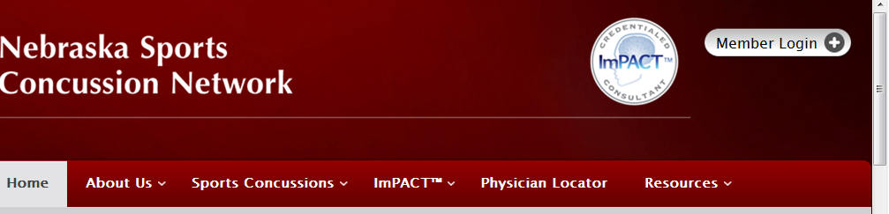

- Key or copy(Ctrl+c)/paste(Ctrl+v) the following information:
Username: admin
Password: nscn2010
- Click on the “Baseline Testing Proctor Login” button

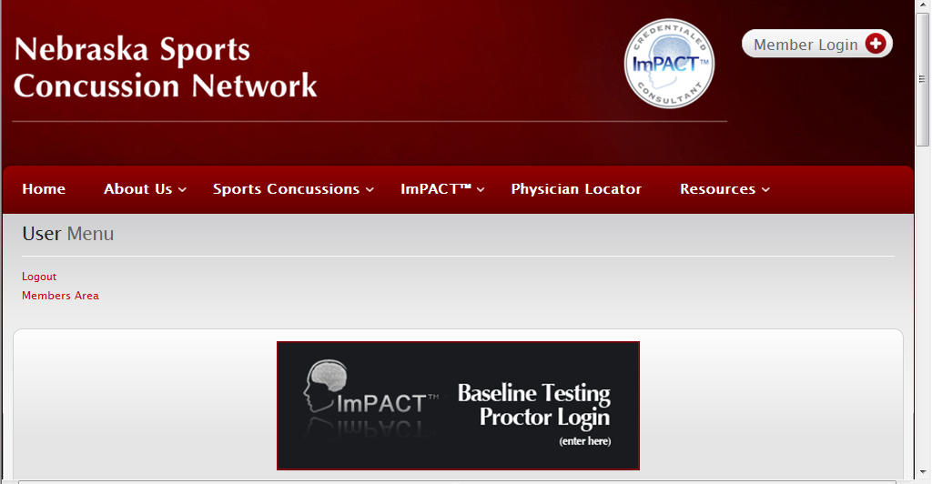

- Click on the Launch Baseline Test button

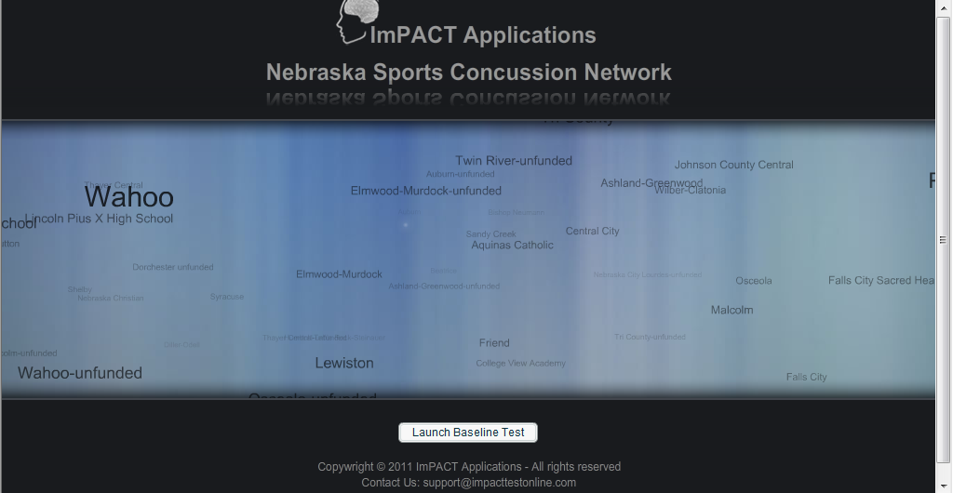

- Key or copy(Ctrl+c)/paste(Ctrl+v) the following information:
School ID: 1aca53d2c8

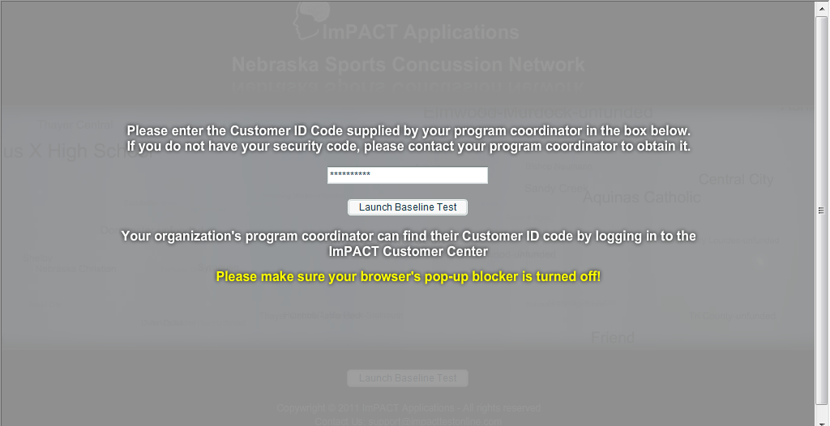
- Click on the Launch Baseline Test button

